Rodgers Mwangi Murigi
rdgrsmwangi@gmail.com
0705452015

Part 1:Test Thinking

Test Cases for Sign up Form
TITLE | STEPS | EXPECTED RESULT
Blank Full Name Field Check | - Leave Full Name field blank  - Fill all other fields as intented.  - Press Create Account button. | Account Creation should be unsuccessful.  Full Name field should be highlighted to the user
Phone Number Field Check | - Input Phone Number field with letters.  - Fill all other fields as intended. | Account Creation should be unsuccessful  Phone Number field should be highlighted to the user.
Email Field Check | - Leave Email Field blank  - Fill all other fields as intended. | Account Creation should be successful.
Password Field Check (Correct Password) | - Input a password in password field with a minimum 8 characters  - Input same password in Confirm Password field.  - Fill all other fields as intended. | Account Creation should be successful.
Password Field Check (Incorrect Password) | - Input a password with less than 8 characters.  - Input same password in Confirm Password Field.  - Fill all other fields as intended. | Account Creation should be unsuccessful  Password field should be highlighted to the user.
Confirm Password Field Check. | - Input an 8-character password in password field  - Input a different password in Confirm Password field.  - Fill all other fields as intended. | Account Creation should be unsuccessful.  Confirm Password field should be highlighted to the user with a passwords do not match message.
Illegal Characters check. | - Input a name in Full Name field with the following characters ‘ “ < >  - Fill all other fields as intended. | Account Creation should be unsuccessful.  The Full Name should be highlighted with a message to input valid name.
Invalid email | - Enter an invalid email in Email field that does not have the @ and . characters.  - Fill all other fields as intended. | Account Creation should be unsuccessful  Email field should be highlighted to the user.

Part 2 : Coding Tasks
Here are screenshots showing my code running and sample results.
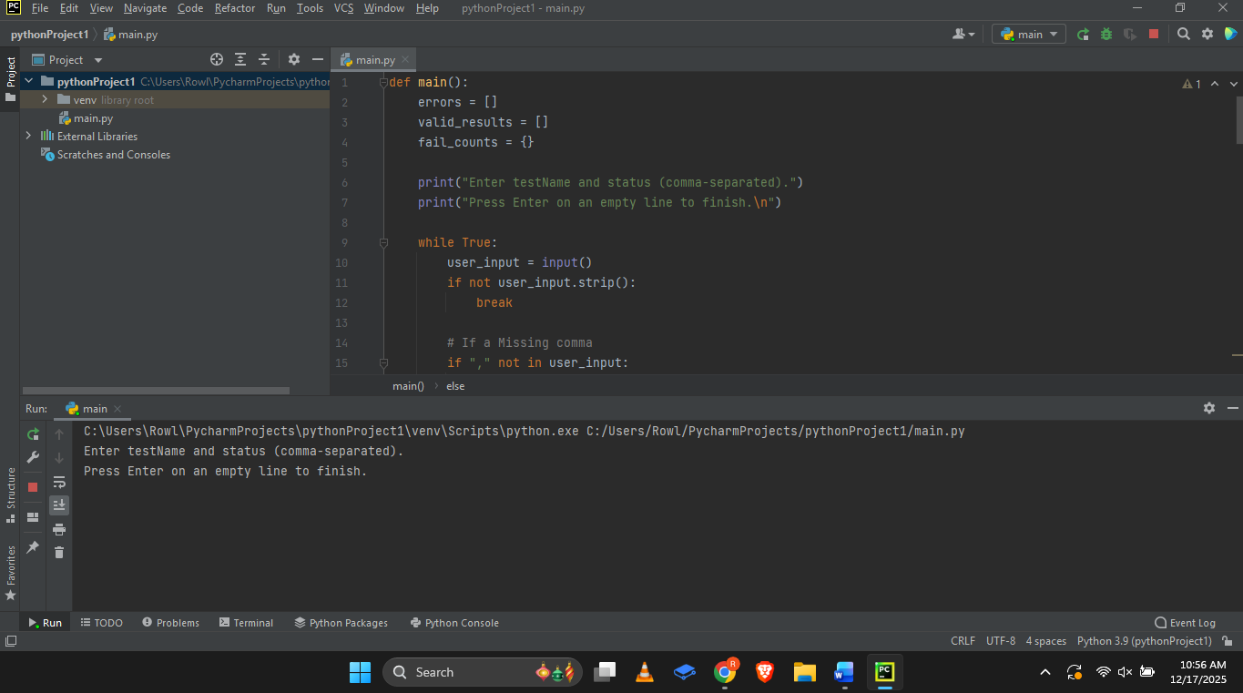

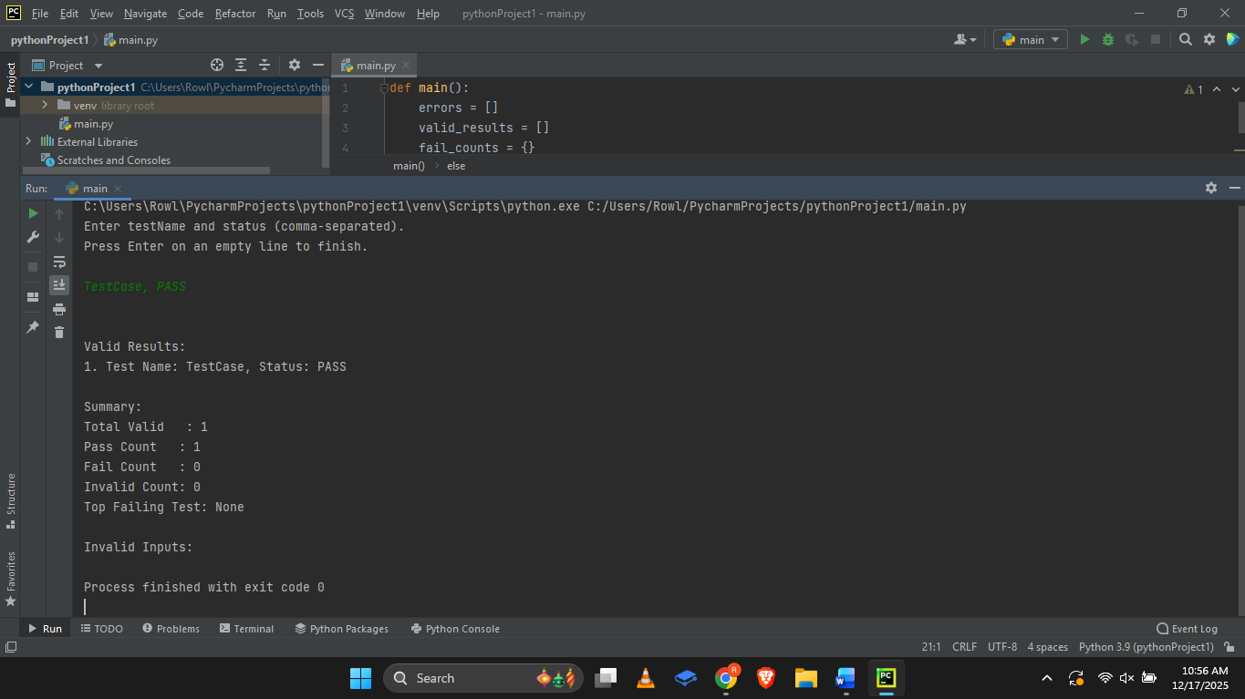

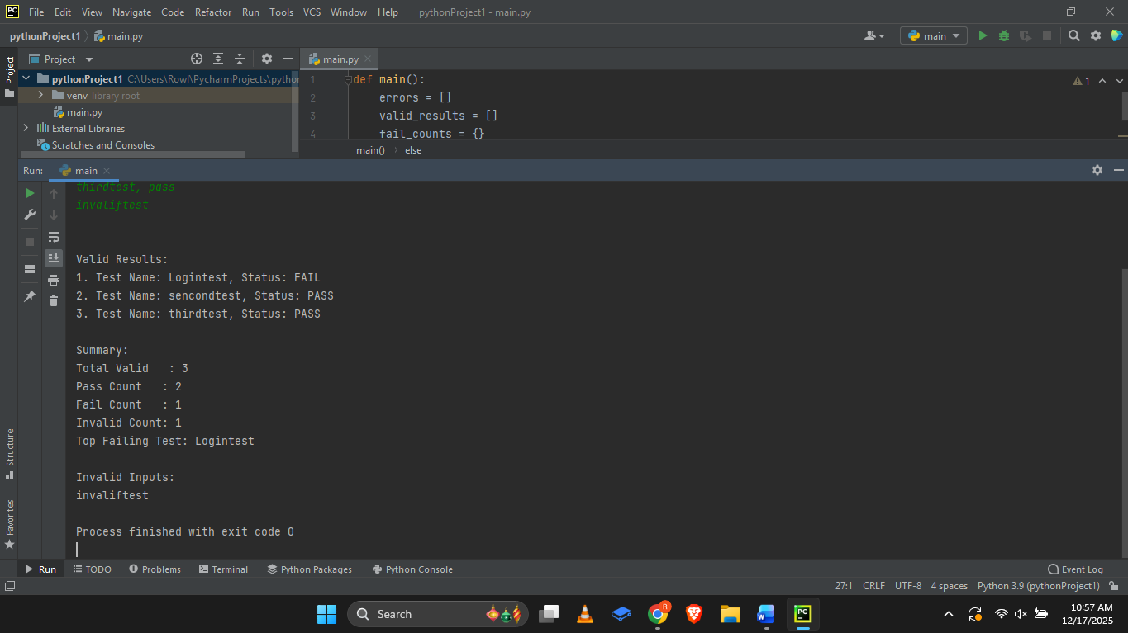

Here is the link to the github repository:
https://github.com/rowlrowl/TestCaseProgram

Part 3: Add Tests
TITLE | STEPS | EXPECTED RESULTS
Normal Input | - Input the a valid line, for instance,  LoginTest, PASS  - Press Enter to pass the results and Enter again to finish | The program recognises the input as valid and logs the results as a PASS.
Mixed case + space | - Input a valid line with mixed case and space, for instance,  LoginTest, PasS  - Press Enter to pass the results and Enter again to finish | The program recognises the input as valid and logs the results as a PASS.
Invalid Lines | - Input the following invalid line, for instance,  BadlIneNoComma  - Press Enter to pass the results and Enter again to finish | The program recognises the input as invalid and logs the results as a INVALID.
Tie-Breaking for topFailingTest | - Input the following lines pressing Enter after each  LoginTest, fail  LoginTest, FAIL  SecondTest, fail  SecondTest, fail  ThirdTest, pass  - Press Enter to finish. | The top failing test should be LoginTest

Assumptions and Improvements
This task was completed with the assumption that the QA tester only requires an input of two fields, test name and status.
If I had more time, I would make the following improvements:
Add more input fields like Description and Date.
I would also create a Graphical User Interface for my program.

